Public Health, Medical Resident, Medical & Nursing Students | 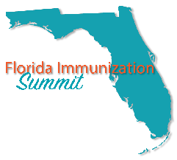

Scholarship Application

Applicant Information
Full Name: |  |  |  | Date:
 | Last | First | M.I.

University Name:

 | Address City | State | ZIP Code

Recipient Phone: |  | Email

Major: |  |  | GPA:
Program:
Please check: Freshman Sophomore Junior Senior Master’s Program Doctoral Program
Please check: Nursing Student Medical Student Medical Resident

Program Advisor:

Will recipient be able to attend all 3 days of the summit, including the Networking Event? Yes No

Will recipient need CE’s or CME’s? Yes No

Name Badge Information
First Name: |  | Last Name:
Company: |  | Position:

Special Request
Please list any ADA Special Needs:
Vegetarian options required: Yes No

Registration is inclusive of all conference materials and CEU/CMEs. Other information will be available electronically.
Travel costs are not included in this scholarship.

This form must be returned by January 20, 2017 at noon. Please email your application to montique.shepherd@flhealth.gov

You will receive an email at the address provided that will notify you of your registration. If you have registration questions, please contact Suwannee River AHEC at 386.462.1551. Thank You!

